#### LET’S PLAY

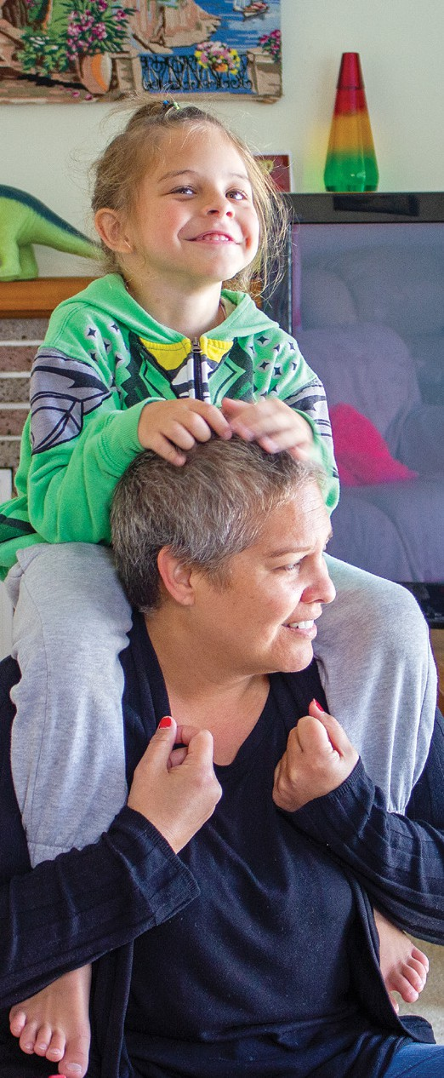

Let’s Play | Autism NZ

AUTISM NZ

AIM

Empower whānau (families) with autistic tamariki (children) through play-based learning.

IMPACT

» Increased joyful interactions between parents and children.

» Improved whānau understanding of their children’s communication styles.

» Enhanced whānau capacity to support their children’s learning.

CONTRIBUTING OUTCOMES

» Parents reported a **90%** increase in playtime with their children.

» **95%** whānau showed increased engagment, indicating a significant shift towards joyful interactions.

» Parents reported using Let’s Play strategies in everyday activities and feeling more confident in their ability to engage with their children.

**LET’S PLAY**

##### Autism NZ

VISION

All whānau with children identified as having social communication challenges have access to the Let’s Play programme as soon as possible to begin parent-mediated support.

MISSION

Demonstrate, develop and deliver a model for implementation that fits the Aotearoa New Zealand context.

OVERVIEW

Let’s Play was developed by Autism NZ’s Neil Stuart and Thecla Moffat. Co-delivered by a professional and a parent coach, the 10-week programme includes three group sessions, six home visits and a celebration to conclude.

Parents are taught how to engage joyously with their children through playful interactions, focusing on their child’s interests and in everyday activities. They also learn how to teach their child life skills to become more independent.

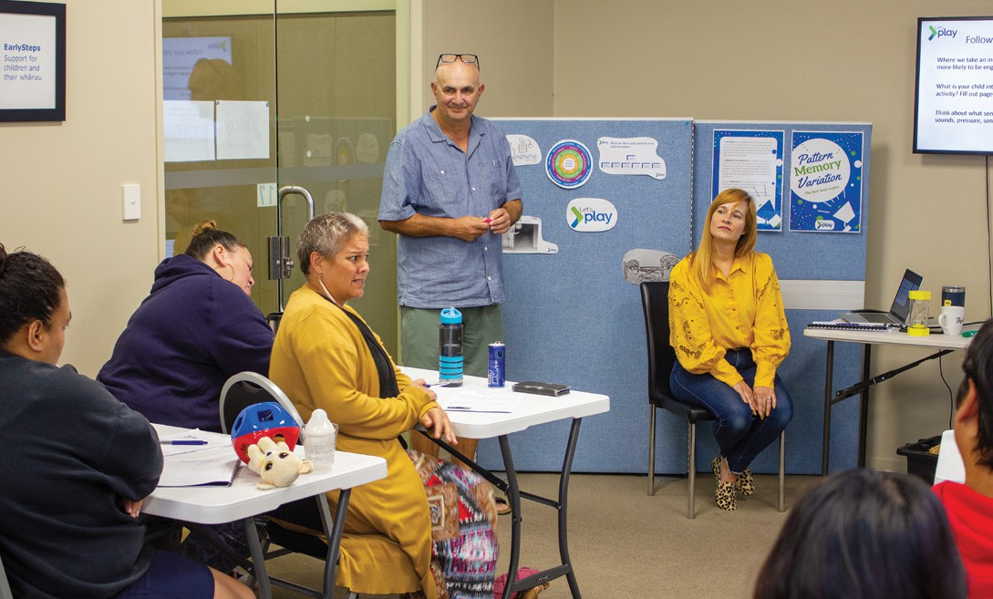

Let’s Play | Autism NZ

LET’S PLAY — OUTPUTS FOR 2023/24

**4**

PROGRAMME ROUNDS

**468**

HOURS OF GROUP SESSIONS

**48**

PARTICIPATING WHĀNAU

TAMARIKI (0–4 YRS)

**39**

**43**

HOURS OF HOME VISITS

|  |  |  |  |  |  |  |  |
| --- | --- | --- | --- | --- | --- | --- | --- |
|  | | | |  | | | |
|  | | |  |  |  | | |
| **36**  BOYS | | | | **7**  GIRLS | | | |
|  |  |  | |  | |  |  |

MĀORI

**8**

**8**

**7**

**6**

**5**

**4**

**1**

INDIAN

NZ EURO

SAMOAN

FILIPINO

TONGAN

CHINESE

Empowering whānau through play

Many whānau participating in Let’s Play initially faced challenges in areas such as:

* Increasing joyful interactions with their tamariki
* Adapting communication styles to understand nonverbal cues
* Prioritising their own well-being

The programme addressed these challenges head-on, with the coaches equipping whānau with simple strategies to increase play and communication at home.

Whānau actively participated in workshops and home visits. They provided valuable feedback, engaged in discussions and actively observed Let’s Play strategies in action.

Video recordings and feedback documented whānau practising these strategies at home, fostering deeper engagement and long-lasting change.

These findings demonstrate

**the effectiveness of the Let’s Play programme in supporting parents to engage more with their autistic tamariki** and help them achieve their potential

as they grow.

**Scan the QR code at right to watch the Let’s Play parent interviews.**

Measurable success

The programme’s influence on whānau and tamariki was evident in several key areas:

1. **Whānau participation**

Strong participation in workshops and home visits demonstrates whānau commitment.

1. **Engagement Levels**

95% of whānau showed improved engagement, indicating a significant shift towards joyful interactions with their tamariki.

1. **Increased Playtime**

Exit survey results showcased remarkable statistics, including:

**100**%

**95**%

**95**%

**90**%

**90**%

**90**%

**65**%

of parents were able to join in with their child’s solitary play

of parents believed their child initiated play more / a lot more

of parents were more / a lot more confident playing with their child

increase in reported parent-child playtime

of parents played more / a lot more with their child

of parents believed their child wanted to play more / a lot more with them

of parents said their daily routines ran more smoothly

*“I feel like it’s opened up a world to engage with and grow into, to build on — and I think that’s what’s so amazing about it.”*

– whānau member

Contributions to TRPET’s strategic priorities

The Let’s Play programme directly addresses two of TRPET’s strategic priorities:



**#1**

**Building Learning Capabilities**

**Fostering Early Engagement** The programme equips parents with skills to engage in playful

interactions with their children from a young age. This early engagement lays a strong foundation for future learning and development.

**Enhancing Emotional Connection** By strengthening the parent-child bond through play, Let’s Play helps create a secure and nurturing environment that is crucial for

early learning.

**Developing Communication Skills**

The programme promotes the development of nonverbal communication skills in both parents and children — a vital

foundation for future language

acquisition and learning.



**#3**

**Addressing Inequalities**

**Supporting Neurodiverse Learners**

By equipping caregivers with skills to understand and communicate effectively with neurodiverse children, the programme empowers them to better support their child’s learning journey.

**Focus on Māori/Pasifika Families** The high participation rate of Māori and Pasifika families suggests

the programme is reaching communities that may traditionally face educational inequities.

**Strengthening Whānau Support** The programme strengthens whānau capacity to support

their children’s learning at home, a known factor in improving

educational outcomes, particularly

for those facing disadvantages.

*“After two years of my son going nowhere, and my wife and me feeling lost, Let’s Play changed all that in 10 weeks. It’s also great to meet other parents who are feeling the same as you.”*

* whānau member

*“The biggest difference through Let’s Play is that [our child] shows us how much he wants to play with us now. He comes up to us and tries to make some joke to start the play.”*

* whānau member

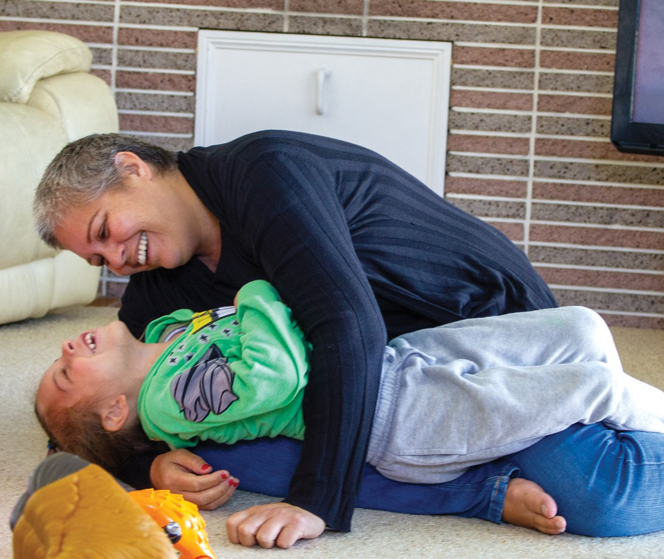

Let’s Play | Autism NZ

Looking ahead

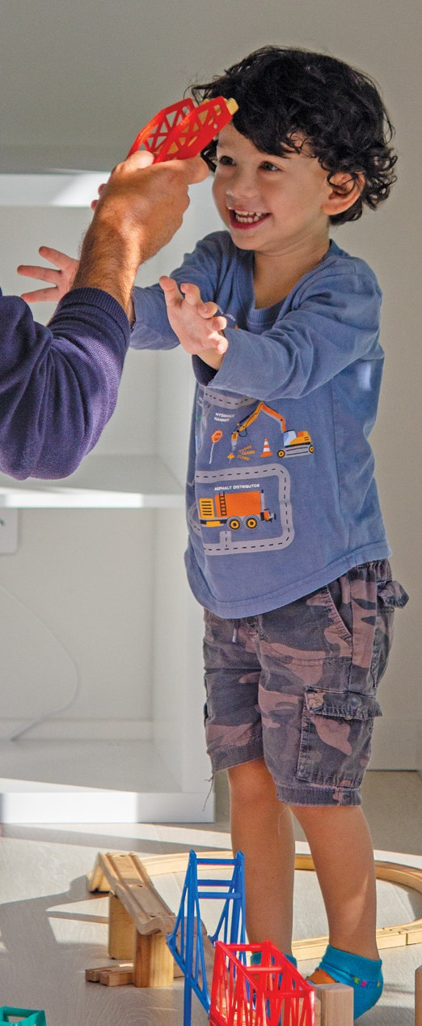

Let’s Play | Autism NZ

While the initial delivery of four programmes to 39 whānau and the creation of training materials are significant achievements, Let’s Play has ambitious plans for the future:

» **Dissemination efforts:** Autism NZ is actively targeting the Ministry of Education and Early Intervention to ensure wider accessibility.

» **Public awareness:** Plans are underway to raise public awareness and garner further support.

» **Funding and expansion:** Securing additional funding remains a key objective to expand coach training and reach, ultimately creating a lasting positive impact on countless families.

» **Investing in the future:** The creation of a Let’s Play “Train the Trainer” manual is a strategic investment in the programme’s sustainability. This valuable resource empowers future coaches to replicate the programme’s success, ensuring its long- term impact.

Let’s Play is more than just a set of strategies. It’s a catalyst for transformation.

By **empowering whānau with the tools and confidence to connect and play joyfully with their tamariki**, Let’s Play fosters a brighter future for all involved.